**LAB – 3**

Name: Gandevia Keval Dharmeshbhai

Sem: VII

Roll No: CE046

Subject: Big Data and Analytics

**Aim:** Interfacing to Distributed File System – HDFS commands and Web GUI file system browser usage.

**Q. 1: Create/Delete a directory/file named ‘Test’ from HDFS web UI in ‘/user/Hadoop’. It should give error message. Read this message and solve the error.**

* We cannot create a file/directory on GUI because we as a Hadoop user has not access to that GUI.

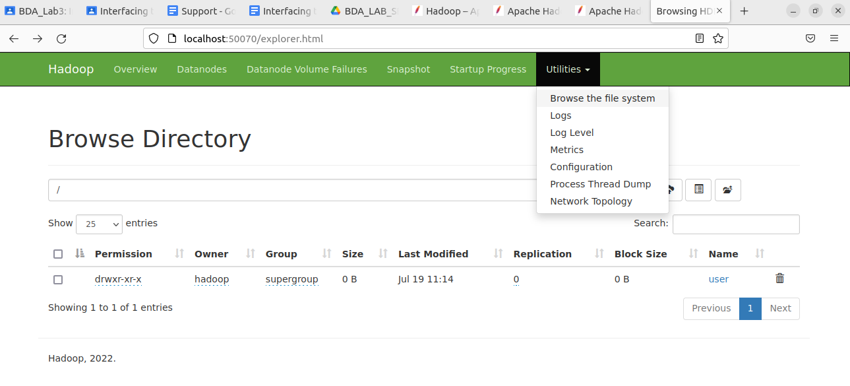

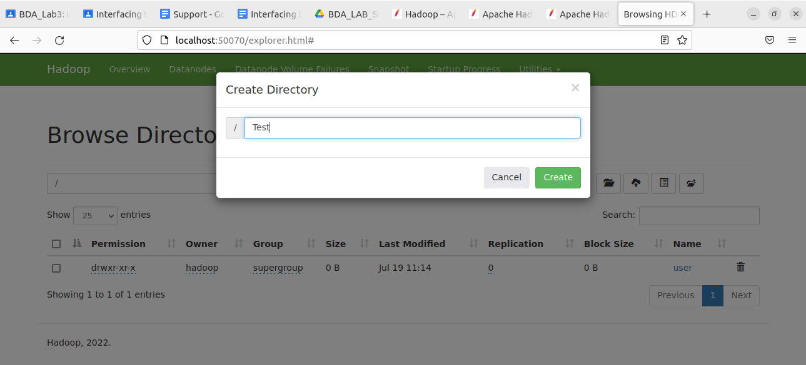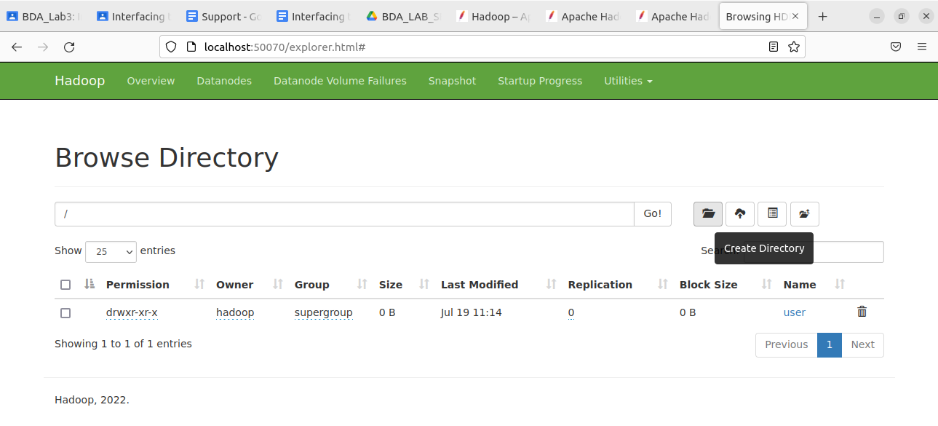

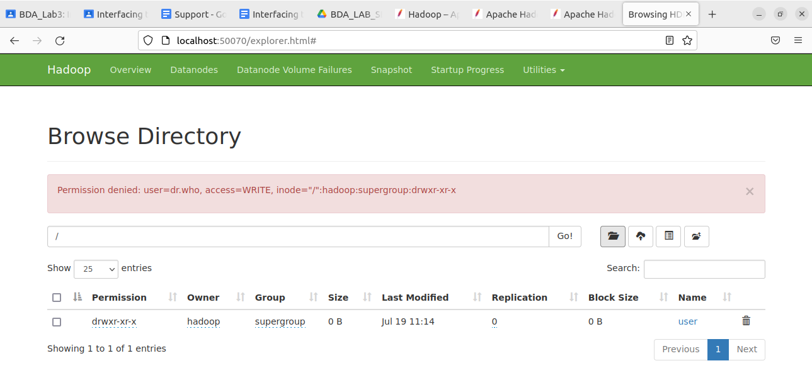

* Stop the server.

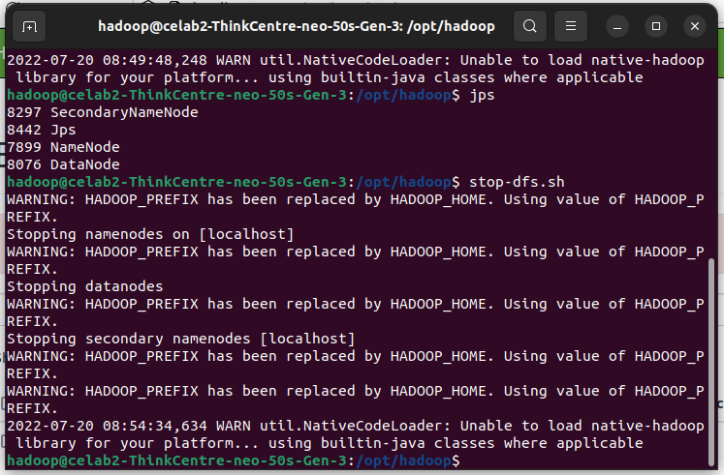

* 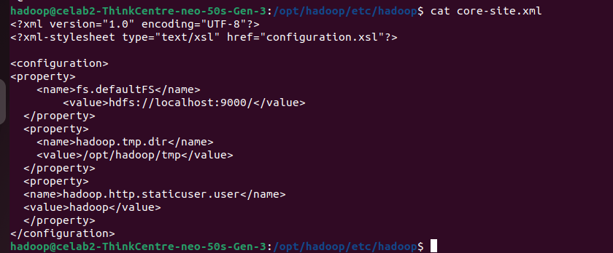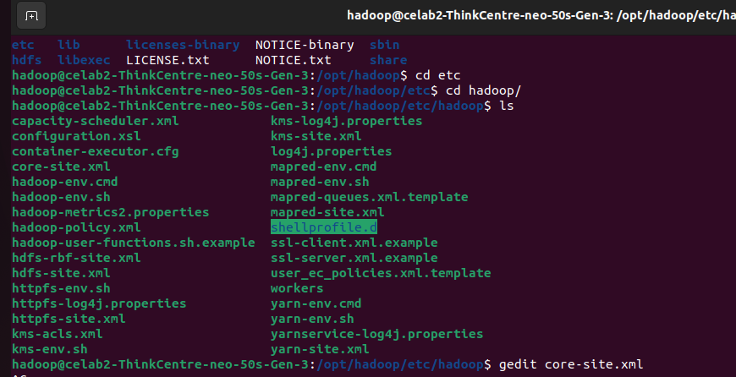We need to edit the core-site.xml and need to add the staticuser with value hadoop.



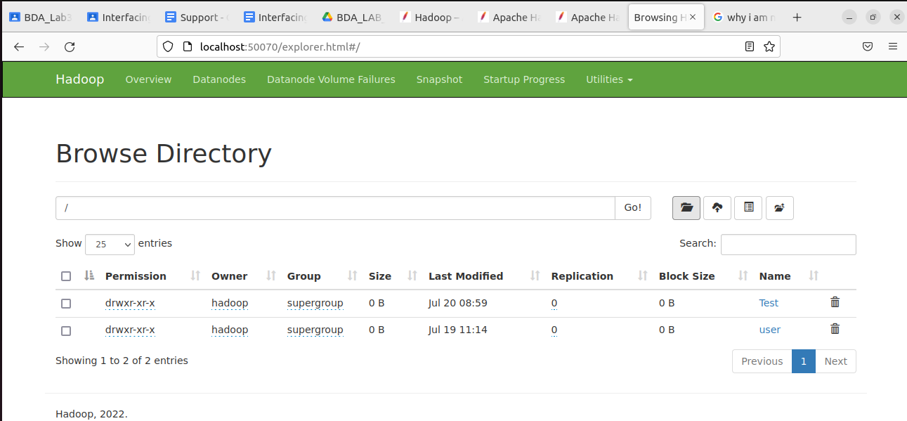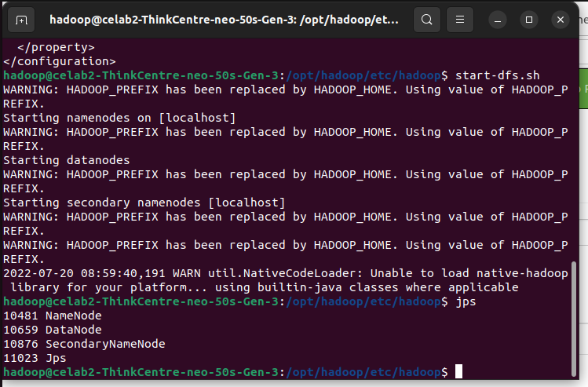



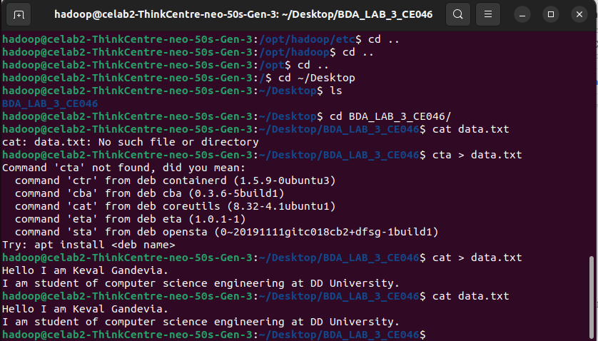**Q. 2: Create a text file in local file system and put the same file in HDFS using appropriate command.**

* 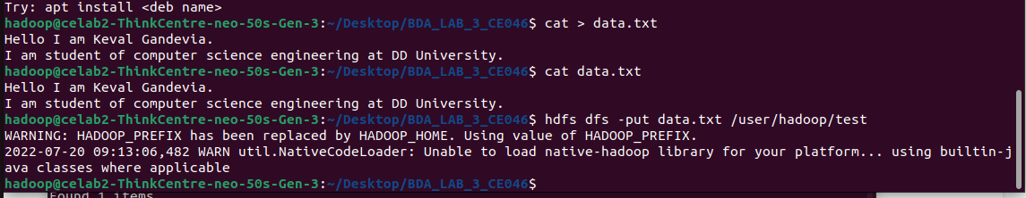We can copy the file from local machine to Hadoop distributed file system using ‘put’ command.

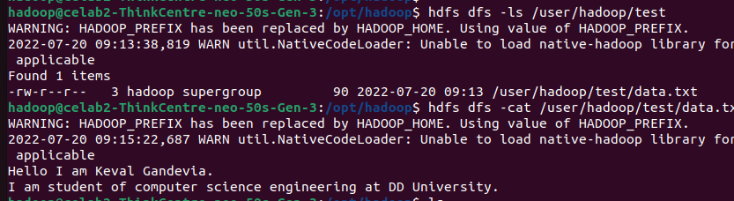



**Q. 3: Display the contents of this file of HDFS on terminal.**

**Q. 4: Download this file of HDFS on local machine and change its contents. Upload this modified file again on HDFS and verify its contents. Also make sure that this file should be deleted from local machine automatically.**

* Modified content. For automatic deletion file from local machine we can use ‘moveFromLocal’ command.

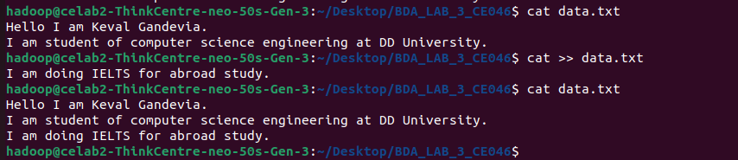

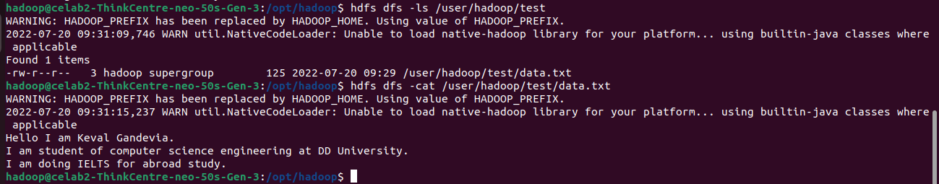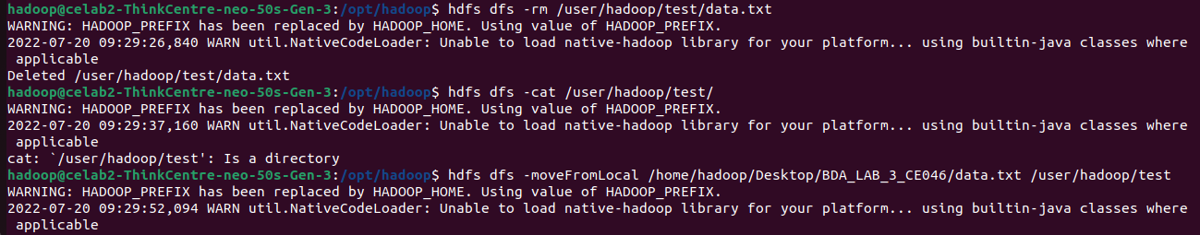



**Q. 5: Find out CLI way to display all file system commands supported by HDFS. Record the list.**

* To find out all file system commands we can use ‘help’ command.

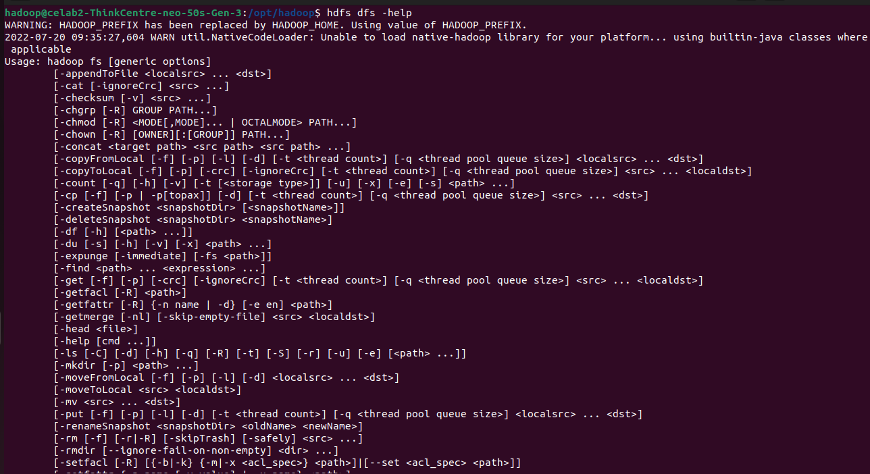

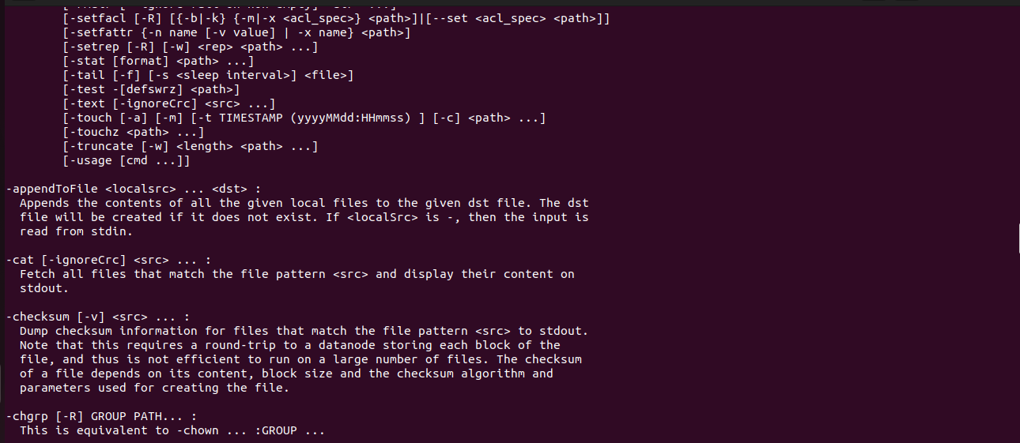

**Q. 6: Perform file operations through Web GUI.**

* We can upload file to distributed file system through web GUI.

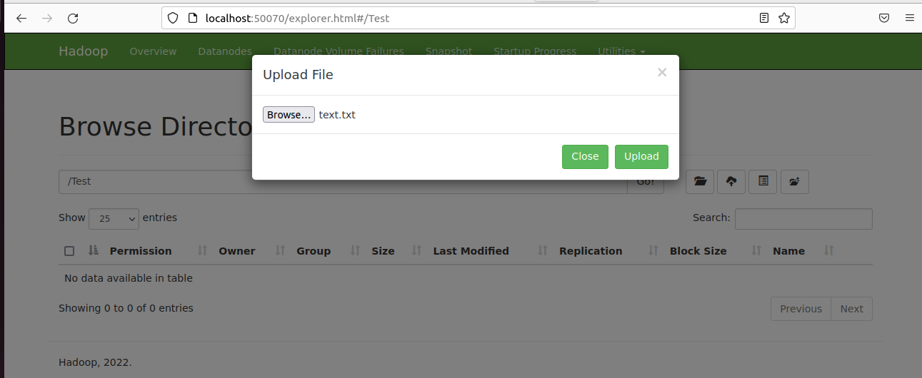

* 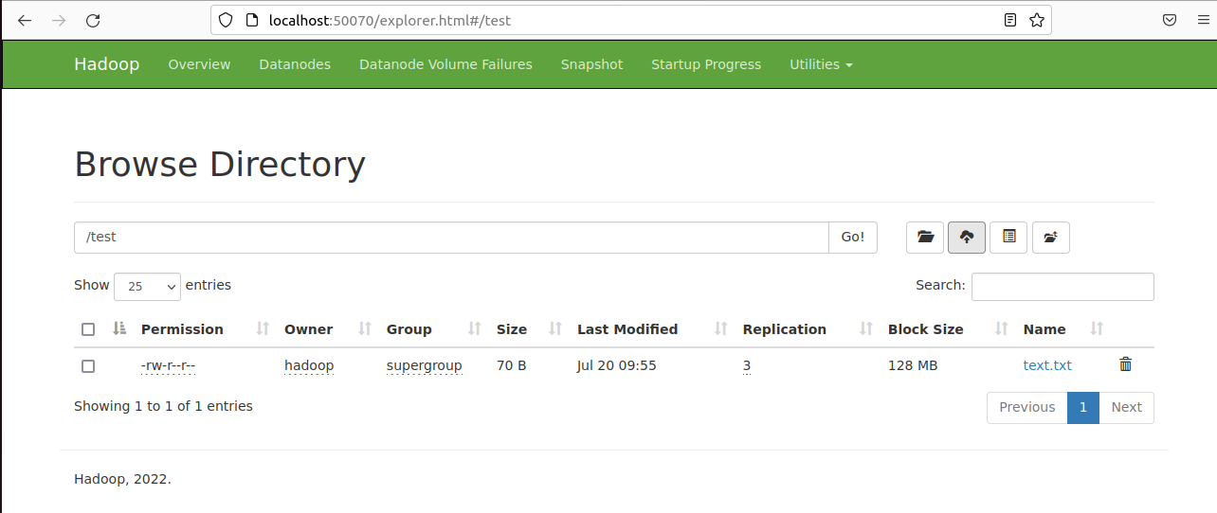Successfully uploaded.
* We can download the file and also can see the content of the file.

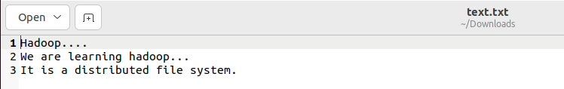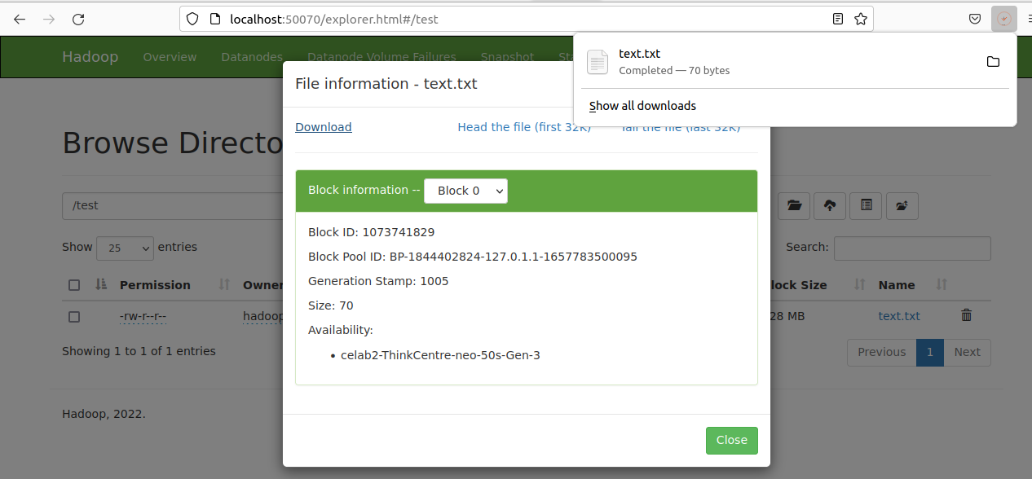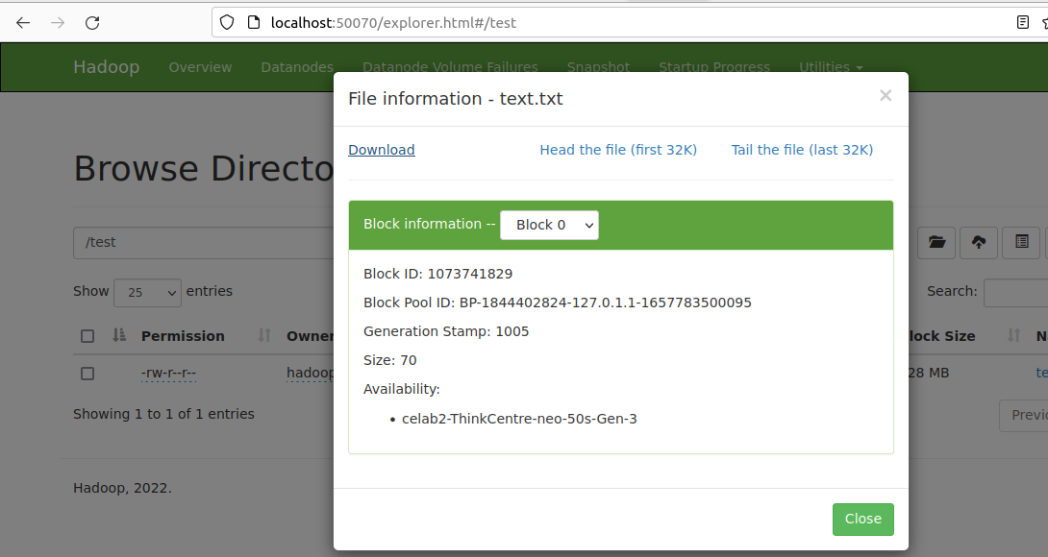

* 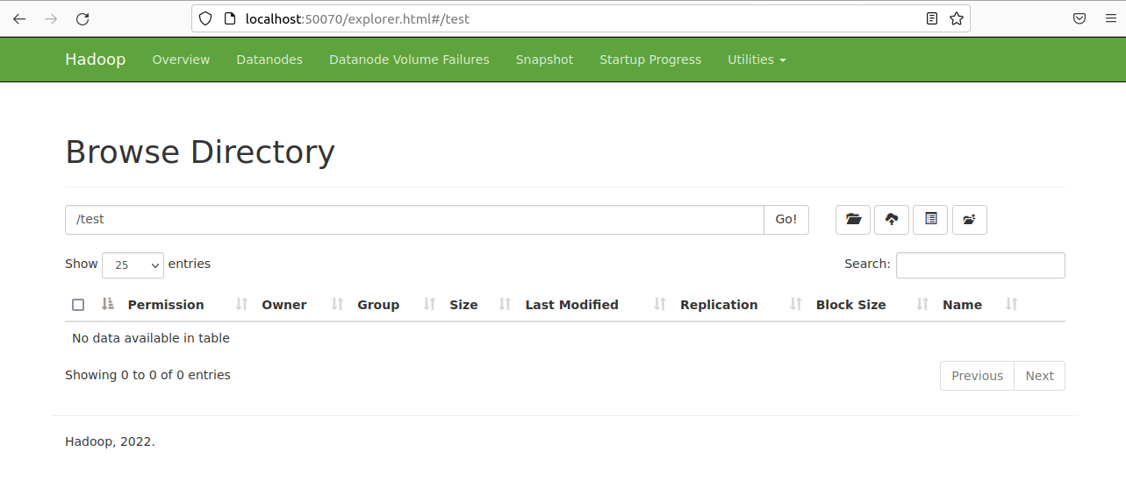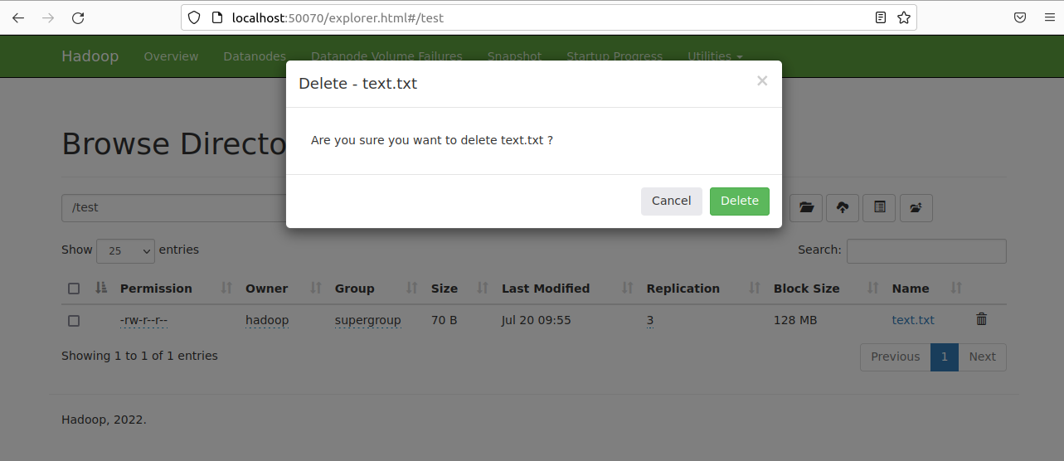We can delete the file from the distributed file system through GUI.